Go to this location and install virtual box

<https://www.virtualbox.org/wiki/Downloads>

goto this and

[https://www.osboxes.org/#](https://www.osboxes.org/)

select virtual box images 🡪 centos 🡪 download virtual box image for centos

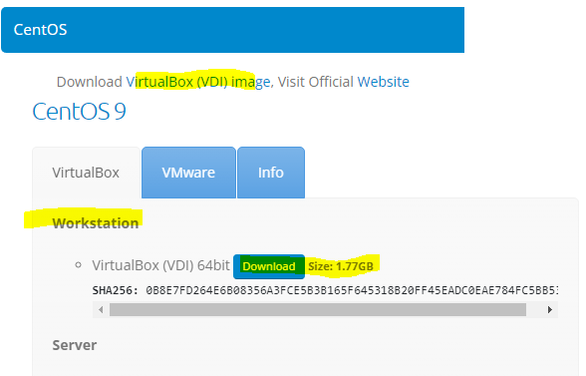

,the main advantage here is u don’t need to install ansbile on target machines, u can only install on source machine (1 machine alone)

Type “Ansible –-version” to check ansbile is installed or not

# Install SSH server on Ubuntu machine

## Why should I install ssh server on my ubuntu??

Ansible will control all nodes using SSH protocol, so wherever ansible Is there, then ssh server must also be present,

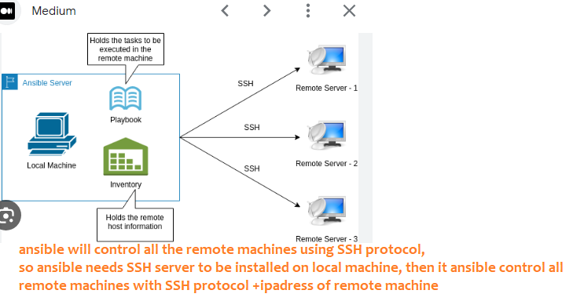

1. To get latest package manager-- Type command “sudo apt update” , “sudo apt upgrade”
2. Install ssh server on the Ubuntu machine –“ sudo apt install openssh-server”
3. to start ssh server “sudo service ssh start”,”
4. To see whether ssh server /ssh service is running or not “sudo service ssh status “
5. Optional-To see whether ssh service is running or not- “sudo systemctl status ssh” –
6. Optional -To enable ssh “sudo systemctl enable ssh”,to start “sudo systemctl start ssh”
7. update the firewall to open the port 22-“sudo ufw allow ssh”
8. to know ip address of ur Ubuntu server “hostname -I” or”ip a”

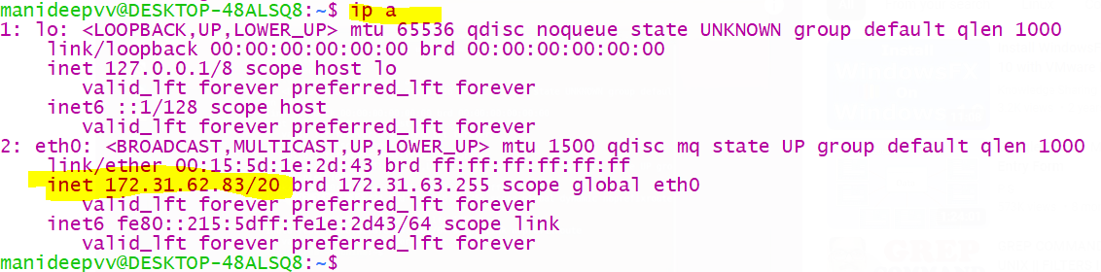

1. so far, we have successfully installed ssh server on Ubuntu machine,

to connect to Ubuntu machine,

* + 1. first in that ubuntu machine ssh server must be installed and
    2. then we should know the ipaddress of that machine and
    3. name of that machine- here machine name is “manideepvv” and password (I used my docker pass- MANIdeep123) to connect to my Ubuntu machine



## **Connect my windows to Ubuntu machine**

1. if ssh server on target machine is stopped, we cant connect, so always ensure ssh server on target machine is running

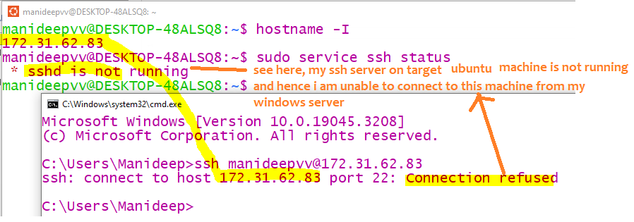

1. now from my windows machine I will connect to my Ubuntu machine

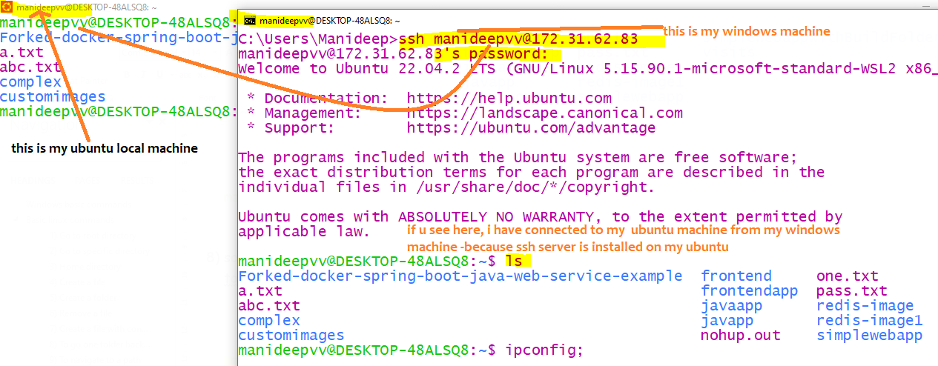

1. if u want to exit the connection from that machine, then simply type exit

# Install Ansible in Ubuntu

Main advantage with ansible is ansible needs only to be installed on current machine, not on remote machines which ansible is going to control

|  |  |
| --- | --- |
| Install ansible in ubuntu | sudo apt install ansbile  or  sudo apt-get install ansible |
| Check installation status | ansible --version |
| To install ssh passpword packages | sudo apt install sshpass |
|  |  |
|  |  |

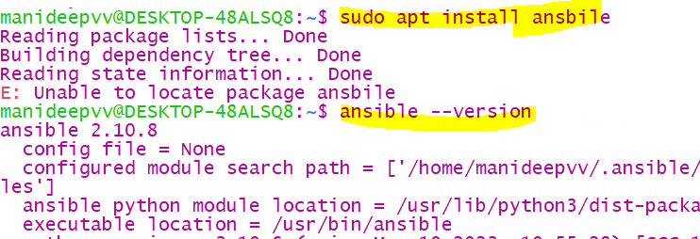

To install SSH password related packages in ubuntu

when u are working with ansible , ansible will connect to target machines using ssh protocol which internally will use ip address of the target machine(if u don’t know ip address u cant connect

sudo apt install sshpass